Rules for Automobiles Travelling in the Same Direction in Adjacent Lane
RULE 10

RULE 10(2)
(2) If neither automobile “A” nor automobile “B” changes lanes, and both automobiles are on or over the centre line when the incident (a “sideswipe”) occurs, the driver of each automobile is 50 per cent at fault for the incident.
Diagram
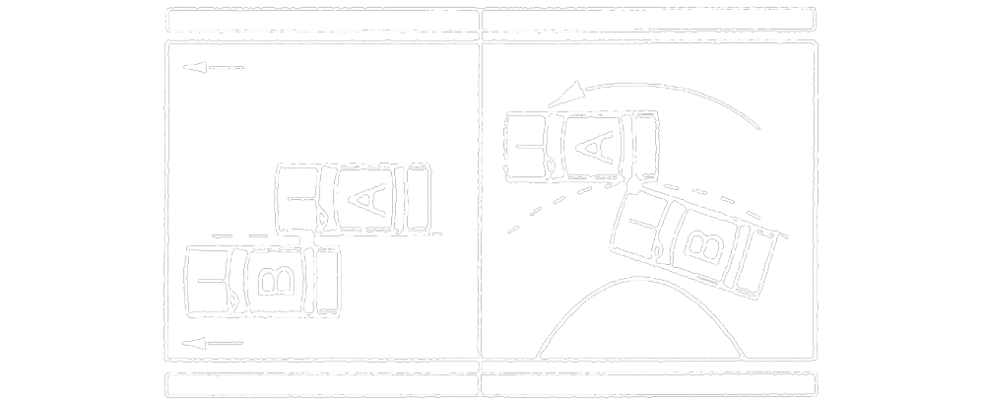
Text alternative: Diagram containing two types of collisions involving 2 vehicles traveling in the same direction, in adjacent lanes. In the first type, automobile “A” and “B” are driving parallel and strike each other on the centre line along the sides of the automobiles. In the second type, automobile “A” and “B” are driving around a curve. Automobile “B” is on the inner lane of the curve and the front passenger side strikes the driver side of automobile “A” on the centre line. This text alternative is provided for convenience only and does not form part of the official law.
R.R.O. 1990, Reg. 668, s. 10 (2).
RULE 10(3)
(3) If the location on the road of automobiles “A” and “B” when the incident (a “sideswipe”) occurs cannot be determined, the driver of each automobile is 50 per cent at fault for the incident.
Diagram
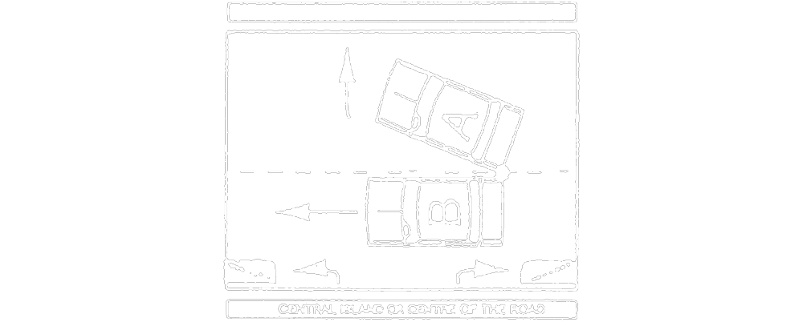
Text alternative: Diagram of a collision. Automobiles “A” and “B” are travelling alongside one another. There is a central island or centre of the road on the other side of Automobile “B”. Automobile “A” turns or transfers out of its lane away from Automobile “B” and the automobiles strike each other on the side near the rear of both automobiles along the centre line. This text alternative is provided for convenience only and does not form part of the official law.
R.R.O. 1990, Reg. 668, s. 10 (3).
RULE 10(4)
(4) If the incident occurs when automobile “B” is changing lanes, the driver of automobile “A” is not at fault and the driver of automobile “B” is 100 per cent at fault for the incident.
Diagram
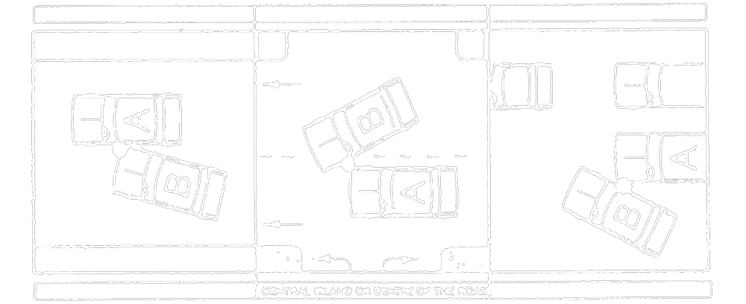
Text alternative: Diagram containing three types of collisions. In the first type, automobile “B” has moved toward automobile “A” and the front passenger side strikes the driver side of automobile “A”. In the second type, automobile “A” is driving in the lane between automobile “B” and a central island or centre of the road. Automobile “B” is changing lanes in front of automobile “A” and the front driver side has struck the front passenger side of automobile “A” in the lane that automobile “A” was in. In the third type, automobile “B” has moved toward automobile “A” and the passenger side of “B” has struck the in driver side front of automobile “A”. This text alternative is provided for convenience only and does not form part of the official law.
R.R.O. 1990, Reg. 668, s. 10 (4).
RULE 10(5)
(5) If the incident occurs when automobile “A” is turning left at an intersection and automobile “B” is overtaking automobile “A” to pass it, the driver of automobile “A” is 25 per cent at fault and the driver of automobile “B” is 75 per cent at fault for the incident.
Diagram
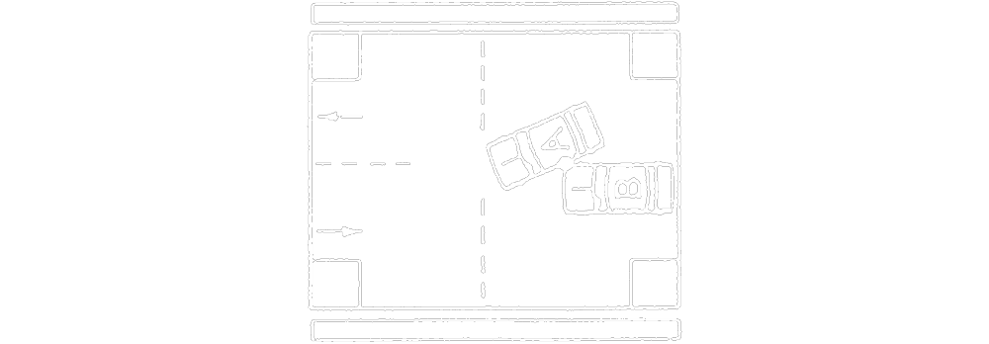
Text alternative: Diagram of a collision. Automobile “A” is turning left across a lane of traffic going in the opposite direction at an intersection. Automobile “A” is turning left and is struck by automobile “B”, which is driving to the left of automobile “A” against traffic. This text alternative is provided for convenience only and does not form part of the official law.
R.R.O. 1990, Reg. 668, s. 10 (5).
RULE 10(6)
(6) If the incident occurs when automobile “A” is turning left at a private road or a driveway and automobile “B” is overtaking automobile “A” to pass it, the driver of each automobile is 50 per cent at fault for the incident.
Diagram
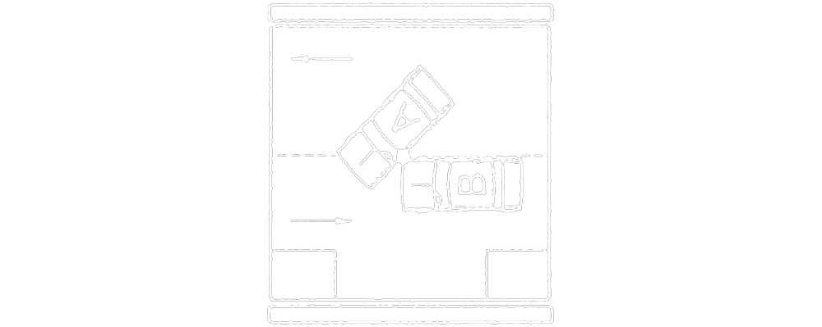
Text alternative: Diagram of a collision. Automobile “A” is turning left across a lane of traffic going in the opposite direction into a roadway. Automobile “A” is turning left and is struck by automobile “B”, which is driving on the left of automobile “A” against traffic. This text alternative is provided for convenience only and does not form part of the official law.
R.R.O. 1990, Reg. 668, s. 10 (6).
RULE 10(7)
(7) If the incident occurs when automobile “A” is turning left at a private road or a driveway and automobile “B” is passing one or more automobiles stopped behind automobile “A”, the driver of automobile “A” is not at fault and the driver of automobile “B” is 100 per cent at fault for the incident.
Diagram
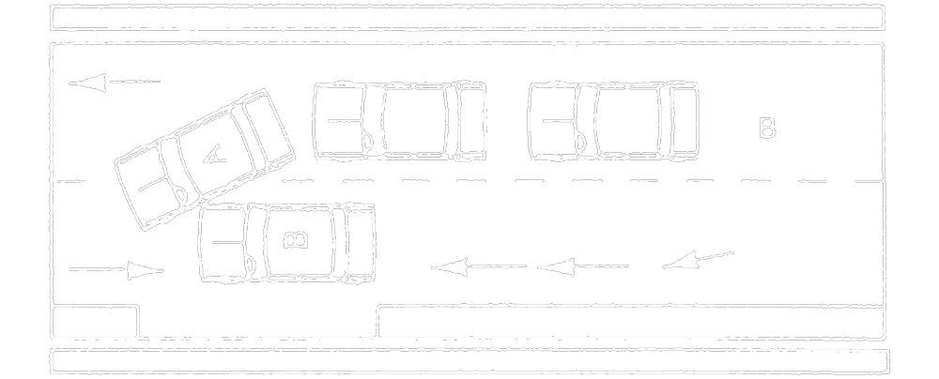
Text alternative: Diagram of a collision. Automobile “A” is turning left across a lane of traffic going in the opposite direction into a roadway. Two other automobiles are stopped behind automobile “A”. Automobile “A” is turning left and is struck on the driver side by automobile “B”, which is driving on the left of automobile “A” against traffic and has passed two other automobiles. This text alternative is provided for convenience only and does not form part of the official law.
R.R.O. 1990, Reg. 668, s. 10 (7).

RULE 11
RULE 11(1)
11. (1) This section applies with respect to an incident involving three or more automobiles that are travelling in the same direction and in adjacent lanes (a “pile-up”). R.R.O. 1990, Reg. 668, s. 11 (1).

RULE 11(2)
(2) For each collision between two automobiles involved in the pile-up, the driver of each automobile is 50 per cent at fault for the incident.
Diagram
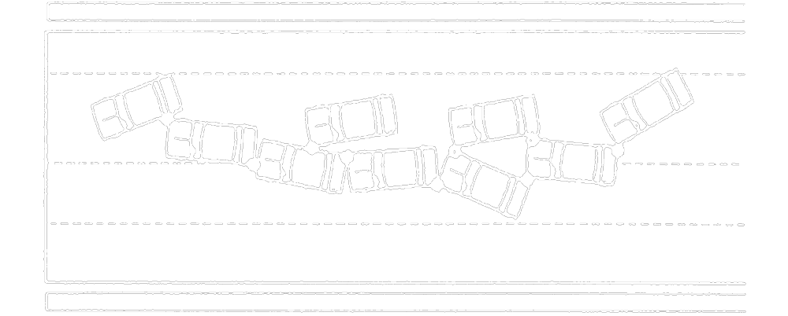
Text alternative: Diagram of a multiple pile up collision. Nine automobiles travelling in the same direction have collided with one another along a roadway. The front automobile did not strike any automobiles but was struck in the side by the automobile behind it. Other automobiles have struck the sides or rear of other automobiles. Some of the automobiles have been struck multiple times by different automobiles, and some have struck multiple automobiles. This text alternative is provided for convenience only and does not form part of the official law.
R.R.O. 1990, Reg. 668, s. 11 (2).

